THERMOSENSITIVE MAGNETOLIPOSOMES FOR MRI-GUIDED DRUG DELIVERY
Marie-Edith Meyre¹, Cyril Lorenzato², Matthieu Germain¹, Pierre Smirnov², Chrit Moonen², Agnès Pottier¹ and Laurent Levy¹

¹ Nanobiotix. Paris. France
² Laboratoire Imagerie Moléculaire et Fonctionnelle. UMR 5231 CNRS / Université Bordeaux 2. France

Abstract:
The development of new activatable drug nanocarriers, with multiple functionalities, presents a promising approach for cancer treatment.
Improved drug delivery and controlled drug release at the tumor site may have considerable benefit by increasing treatment efficacy while reducing side effects and toxicity. Further, the possibility to monitor both nanocarrier accumulation and drug release via current clinical imaging techniques may be particularly relevant for an optimal treatment.
Within the European project “Sonodrugs”, we investigated the opportunity of triggering the drug release from new nanocarriers (temperature and pressure-sensitive) thanks to High Intensity Focused Ultrasounds (HIFU) and monitoring the release profile of the drug at the tumor site thanks to Magnetic Resonance Imaging (MRI) imaging.
A new versatile thermosensitive liposome has been designed and developed to efficiently encapsulate a drug (doxorubicin) and a contrast agent (superparamagnetic iron oxide nanoparticles).
Doxorubicin release profile from the thermosensitive liposome upon heat activation was characterized using the autoquenching properties of the molecule. Fluorescence intensity of the doxorubicin is quenched when the molecule is confined inside the liposomes, but is recovered when the doxorubicin is released from the liposomes in the external media. Efficient release of the doxorubicin was observed when the thermosensitive liposome solution was heated above its melting temperature (T_{m}) corresponding to the main gel-to-liquid crystalline phase transition of the liposome composition. Whereas, non significant doxorubicin release was observed upon aging the thermosensitive liposome solution at 37°C (below T_{m}).
Magnetic Resonance Imaging (MRI) experiments were performed on a 1.5 T clinical MRI Philips Achieva, using a head SENSE coil, to monitor the release of the drug at temperature above T_{m}. Thermosensitive liposomes encapsulating superparamagnetic iron oxide nanoparticles (TSL), non-thermosensitive liposomes encapsulating superparamagnetic iron oxide nanoparticles (NTSL), and free nanoparticles in solution (free NP) were tested. A marked positive contrast enhancement was observed on Magnetic Resonance images upon heat activation (above T_{m}) of the thermosensitive liposome (TSL). On contrast, no change in the MR images was observed for both the non-thermosensitive liposome (NTSL) and the free nanoparticles (free NP) (Figure 1). The signal changes were assessed by longitudinal and transverse relaxivity measurements, r₁ and r₂* respectively. A marked decrease in the ratio r₂*/ r₁ was observed for TSL only, upon heating the samples above T_{m}.

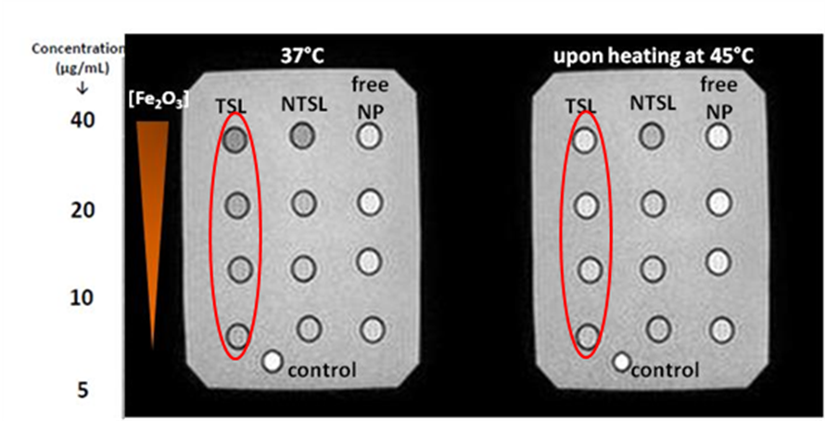
Figure 1 : Evolution upon heating of Magnetic Resonance (MR) signal at 1.5 Tesla of iron oxide encapsulated in thermosensitive (TSL) and non-thermosensitive liposomes (NTSL), and free nanoparticles (free NP).
Furthermore, heat activation (above T_{m}) using HIFU, and subsequent thermosensitive liposome membrane permeabilization was demonstrated through T₂*-mapping, strongly suggesting the possibility of real-time imaging of drug release.
In vitro toxicity and efficacy assays, and in vivo biodistribution and antitumor efficacy are to be investigated to confirm the full potential of such new type of nanocarriers for cancer treatment.

